**Unpacking the UN Pact for the Future and its implications for Science – A Webinar**

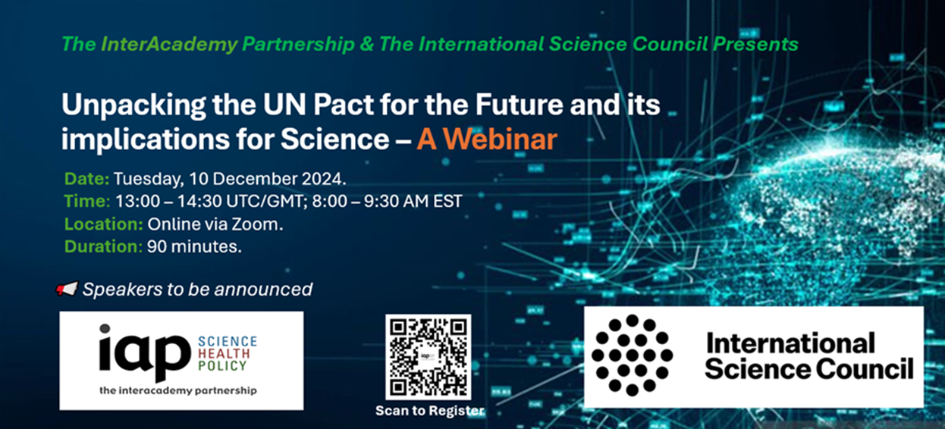

**Background**

In September 2024, after months of negotiations, world leaders adopted the [Pact for the Future](https://www.un.org/sites/un2.un.org/files/sotf-pact_for_the_future_adopted.pdf) at the United Nations General Assembly and [Summit of the Future](https://www.un.org/en/summit-of-the-future). Dubbed a “once-in-a-generation opportunity,” this landmark framework is intended to reshape multilateral cooperation and strengthen global governance for the sake of present and future generations. Together with its two annexes—the *Global Digital Compact* and the *Declaration on Future Generations*—the Pact addresses a broad range of critical issues, including sustainable development, climate change, digital cooperation, human rights, gender equality, peace and security, youth and future generations, and the transformation of global governance.

As these issues are inherently interdisciplinary, the Pact for the Future has significant implications for the global scientific community, including academies of sciences, medicine, and engineering. The Pact underscores that science, technology, and innovation are essential for accelerating progress across the UN's three pillars of peace, security, and development, emphasizing the need for scientific evidence to inform decision-making and guide sustainable policies in areas like climate change, digital transformation, and sustainable development. Greater international collaboration in science and technology is seen as a crucial driver for achieving these goals, particularly in ensuring equitable access to life-changing scientific breakthroughs.

While the commitments made at the summit aim to strengthen scientific collaboration globally, many academies may not be fully aware or have fully digested the Pact’s implications on their work. This webinar seeks to unpack the outcomes of the Summit of the Future and the Pact for the Future, with a particular focus on their relevance to science, international scientific collaboration, and the work of national academies. Through this webinar, the **InterAcademy Partnership (IAP)** and the **International Science Council (ISC)** will bring together experts on the UN system, international science policy and collaboration to discuss the opportunities and challenges ahead and provide a platform for leaders of science academies to engage and seek clarification on relevant topics. The event will be recorded and summarized on the IAP and ISC websites ([see past webinars](https://www.interacademies.org/project/iap-webinar-series)).

**Webinar Date and Time**

* **Date:** Tuesday, 10 December 2024.
* **Time**: 13:00 – 14:30 UTC/GMT; 8:00 – 9:30 AM EST ([See time in your city](https://www.timeanddate.com/worldclock/meetingdetails.html?year=2024&month=12&day=10&hour=13&min=0&sec=0&p1=263&p2=136&p3=170&p4=122&p5=28&p6=152&p7=111&p8=45)).
* **Location:** Virtual on Zoom.
* **Duration**: 90 minutes.

**Registration:** All participants, including speakers, should register using this link. <https://nasem.zoom.us/meeting/register/tJwldO2prjouHNa2N9-2FjrXOCvKw81BMBHE>

**Agenda and Speakers**

***Speakers to be announced.***

1. **Welcome and Opening Remarks (5 mins)**  
   *Brief overview of the webinar's purpose and the significance of the UN Summit of the Future.*
2. **Keynote Presentation (15 mins)**  
   *A deep dive into the Pact for the Future, key outcomes, and the journey past, with a focus on science and international cooperation, presented by a UN representative or an expert in international policy.*
3. **Panel Discussion: The Pact for the Future and Global Scientific Collaboration (30 mins)**  
   *Experts in international science collaboration, and representatives from IAP member academies discuss how the Pact could influence global science cooperation, and the roles academies could play.*
4. **Open Discussion and Q&A Session (25 mins)**  
   *Open Q&A where IAP members can engage with panelists to discuss challenges, opportunities, and specific regional concerns.*
5. **Closing Remarks and Next Steps (5 mins)**  
   *Summary of key takeaways and suggested actions for IAP members.*

**Contact information**

The webinar is organized by the InterAcademy Partnership (IAP) as part of its ongoing Webinar Series. Inquiries should be sent to Moses Ogutu at [mogutu@nas.edu](mailto:mogutu@nas.edu) or IAP Secretariat at [secretariat@iapartnership.org](mailto:secretariat@iapartnership.org).